# Command 1: Query: list the supplier number and supplier name for those suppliers who ship every green part.

# This should return supplier S6 (Nicola Giannberti).

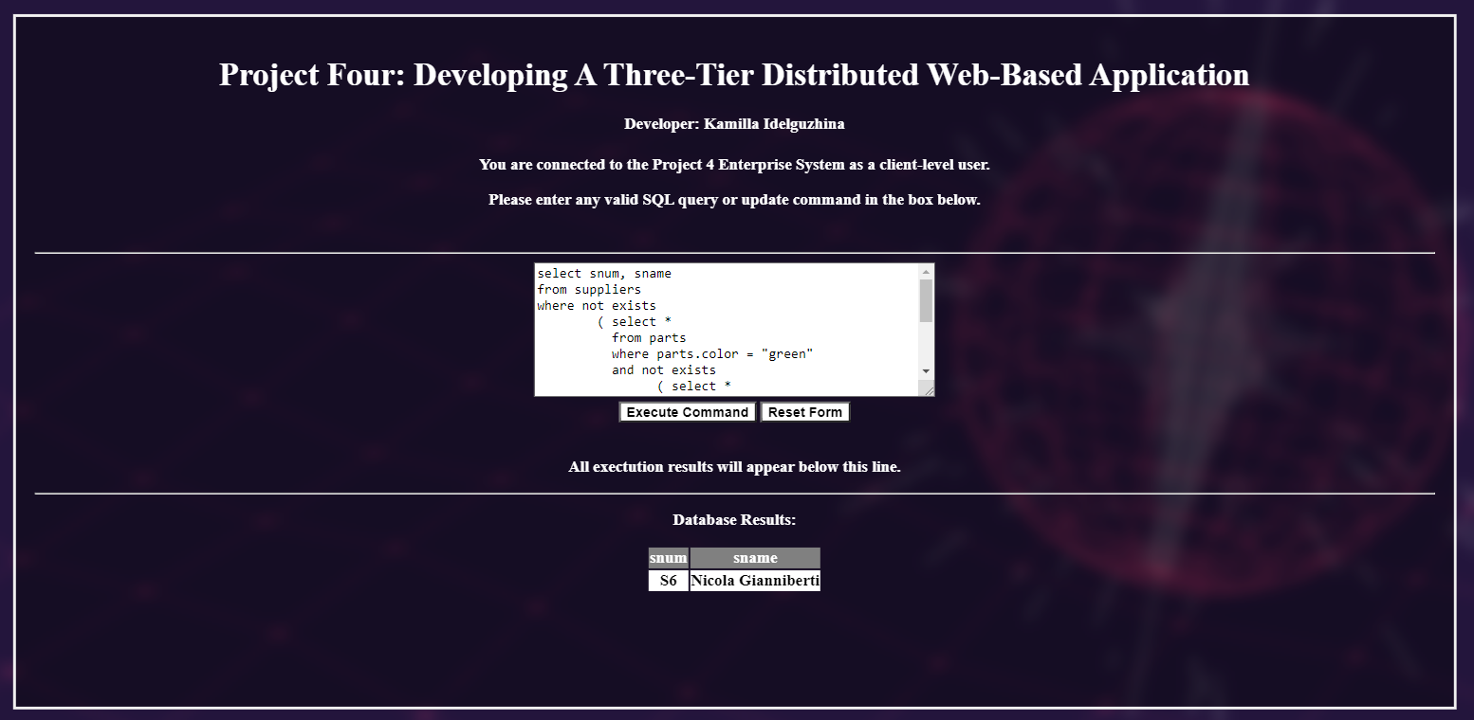

# Command 2: This command will not execute for the client-level user.

# Output should show the message indicating that the command was denied to the client-level user.

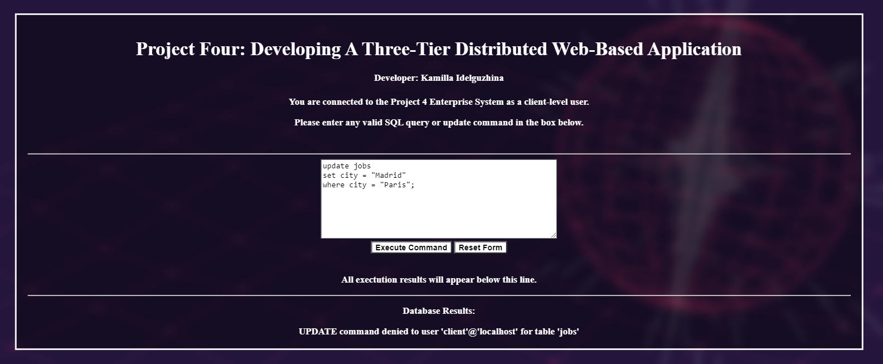

# Command 3: This is a basic select command using an aggregation operator

# Business logic not triggered and no table is updated.

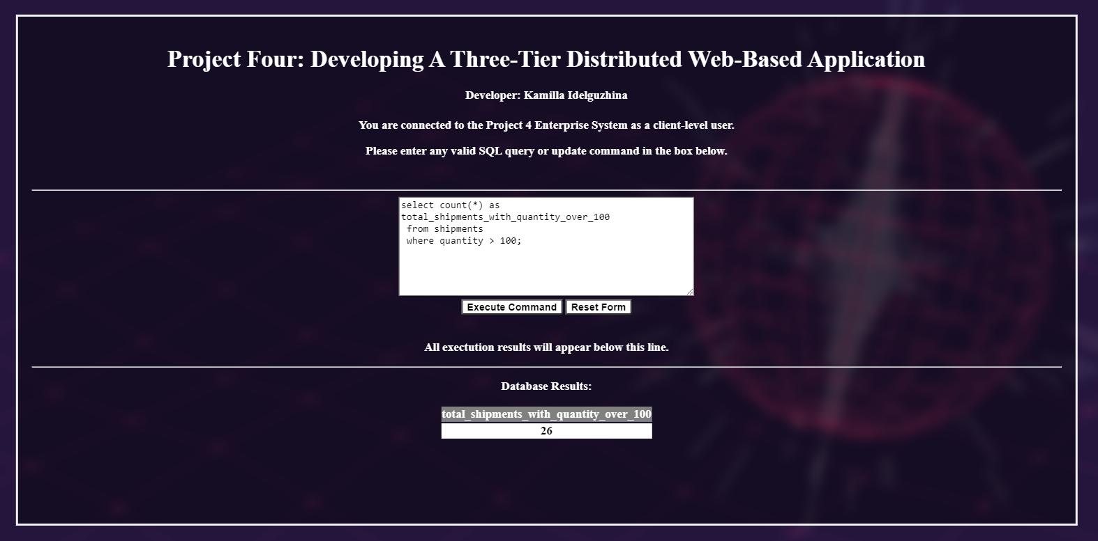

# Command 4: This command will not execute for the client-level user.

# Output should show the message indicating that the command was denied to the client-level user.